User Manual

1 Application overview :

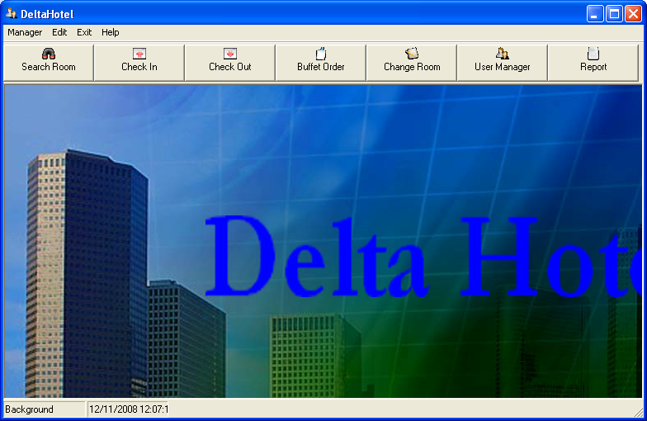

2 How to Login:

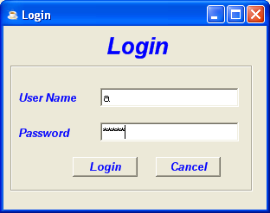
Add your name account to access.
Add password your account to access.
Press to execute your account.
Press cancel to clear your text .

3 How To access all form from main from:

1
2
3
4
5
6
7

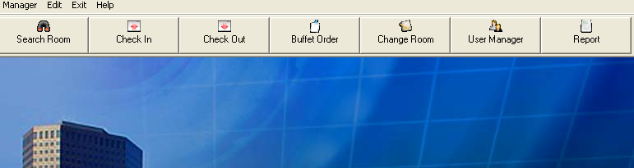

From main menu you can press:

Button 1 to access to Search Room form.
Button 2 to access to Check In Room form.
Button 3 to access to Check Out Room form.
Button 4 to access to Buffet Order form.
Button 5 to access to Change Room form.
Button 6 to access to User Manager form.
Button 7 to access to Report form.

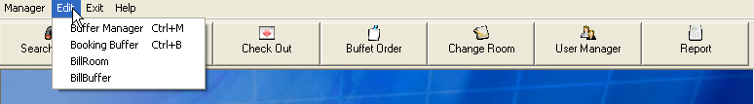
1
2
3
4

From drop down list Edit you can choose:

String text 1 to access Buffet Manager form.
String text 2 to access Booking Buffet form.
String text 3 to access BillRoom form.
String text 4 to access BillBuffet form.

1
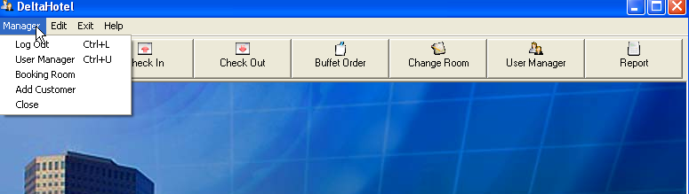
2
5
4
3

The same below you can press:
String text 1 to Logout from the application.
String text 2 to access User Manager form.
String text 3 to access Booking Room form.
String text 4 to access Add Customer form.
String text 5 to close application.

4 How To Input Food Items and Buffet to Database:
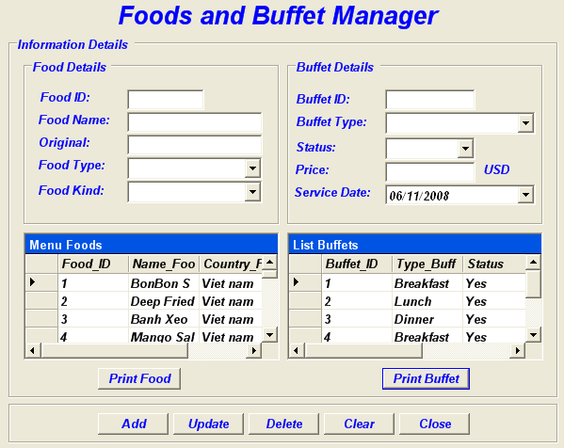
1
2
7
5
3
4
6

From form Foods and Buffet manager.

We can press :
Button 1 to print list of foods.
Button 2 to add food and Buffet.
Button 3 to update record to DataGrid.
Button 4 to delete food item or buffet.
Button 5 to .clear text from all fields.
Button 6 to close form.
Button 7 to print list of buffet information.

5 .How to booking buffet from form Booking Buffet:

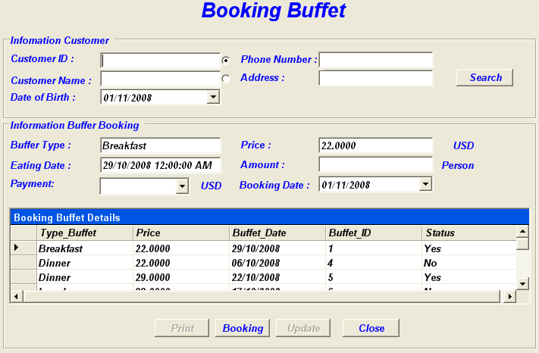
2
1
3
4
7
6
5

From form Booking Buffet we can press:

Button 1 to choose with text field Customer ID will be input to search by Customer ID.
Button 2 to choose with text field Customer name will be input to search by Customer Name..
Button 3 to search customer information with text field specify.
Button 4 to print bill customer booking imformation.
Button 5 to save input imformation to DataBase.
Button 6 to update record to DataGrid.
Button 6 to close application.

6 How to user Buffet Order form to order buffet.
2
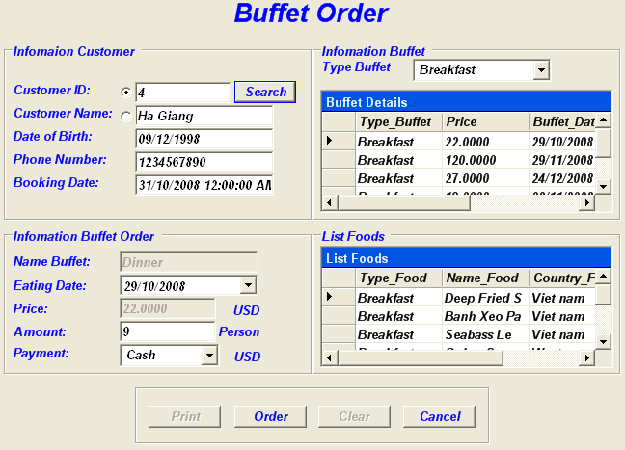
1
4
5
6

The same with form Booking buffet we can press:

Button 1 to search customer imformation.
Button 2 to select type of buffet (Breakfast, Dinner or Lunch) to binding data from DataGrid to text field near by.
Button 3 to print customer order imformation.
Button 4 to save data to database.
Button 5 to clear text fields
Button 6 to close Order Buffet Form..

7 How to user Bill Buffet form to check bill buffet.

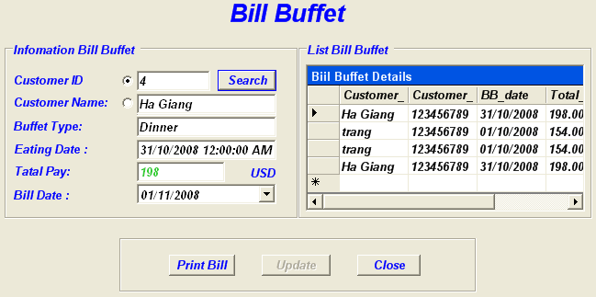
1
4
3

2

From Bill Buffet form we can press:

Button 1 to search customer imformation like form Booking Buffet.
Button 2 to print bill buffet to customer.
Button 3 to update data to DataGrid.
Button 4 to close Bill Buffet form.

8. How to Form User Manager.

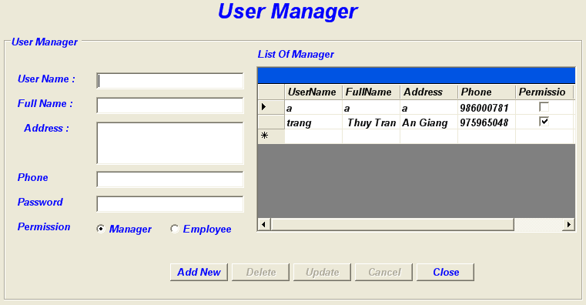
1
2
3
4
5
6

Datagrid 1 row record is checked the row data will bind to all text fields near by DataGrid.

Buuton 2 to new account for user or manager. If you use employee account you only change your account. Otherwise if you adminstration you will have full control.
Button 3 to delete account from database.
Button 4 to change account user and administration.
Button 5 to clear text fields.
Button 6 to close User Manager form.

9.How to use Bussiness Report Form:
3
2
1
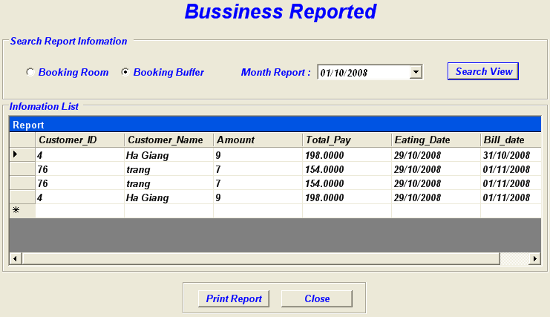
5
4

After we press:

Button 1 to get Bill of Room.
Button 2 to get Bill of Buffet.
Button 3 use to search total bill in one month of Buffet or Room.
Button 4 to print report into another form.
Button 5 to close form.

10. How to search room from Search Room Form.

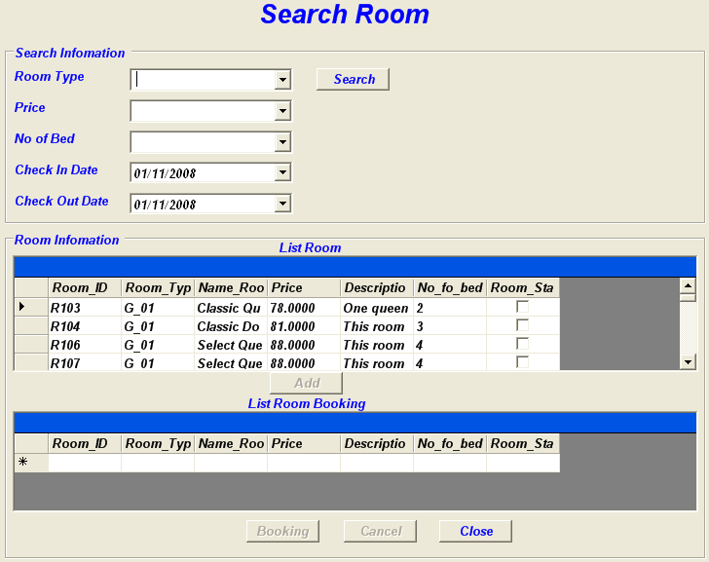
1
2
5
4
3

Button 1 use to search room in needs after you enter text into text fields.
Button 2 to add room imformation to Datagrid below to booking room.
Button 3 to clear text from text fields.
Button 4 to close form.

11. How to check in room from checkin Room Form.

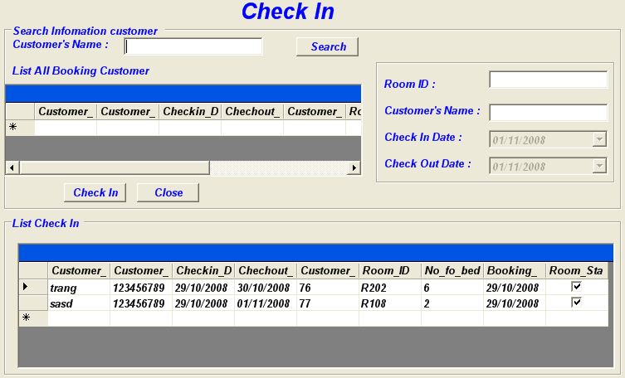
1
2
3

Button 1 to search customer to bind to Datagrid below.
Button 2 use to check in and save data to database.
Button 3 use to close form.

12. How to use Checkout form to check out.

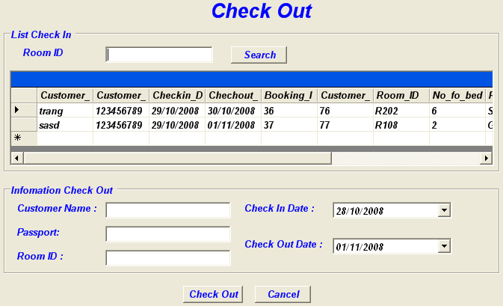
1
2
3

Button 1 use to search room by room ID and data will be add to DataGrid below.
Button 2 use to check out after you press to row data from DataGrid.
Button 3 use to close form.

13. How to use Change Room to change room.

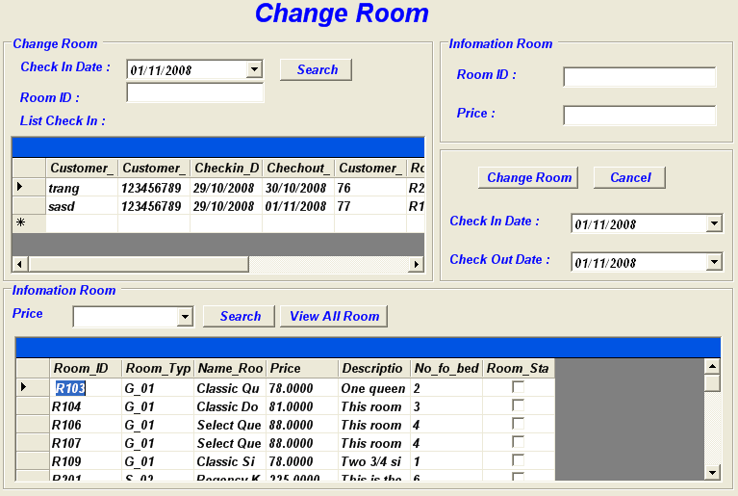
3
5
4
1
2

Button 1 use to customer check in.
Button 2 use to change room after Room information is select.
Button 3 use to close form.
Button 4 search room with price of room.
Button 5 use to show all room of the hotel.

14. How to use Booking Room to book room.

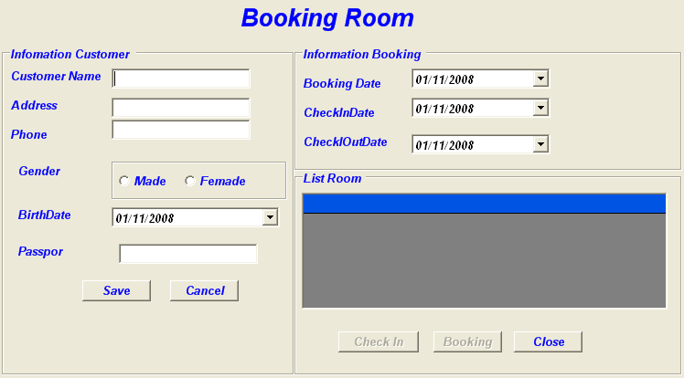
2
1
4
3
5

Button 1 customer information to book room.
Button 2 use to clear text fields.
Button 3 use to save check in information.
Button 4 use to save information booking room.

15. How to use Add Customer form to add customer information.

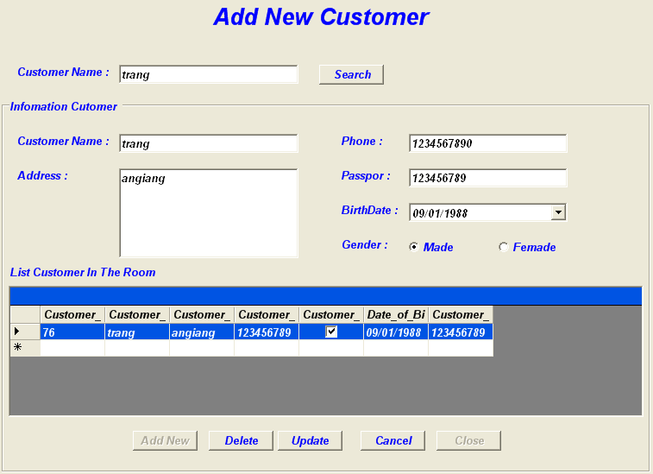
1
2
3
4
5

The way to use this form the same with User Manager form.

Button 1 use to add customer information to database.
Button 2 use to delete customer information.
Button 3 use to change customer information.
Button 4 use to clear text fields.
Button 5 use to close form.

